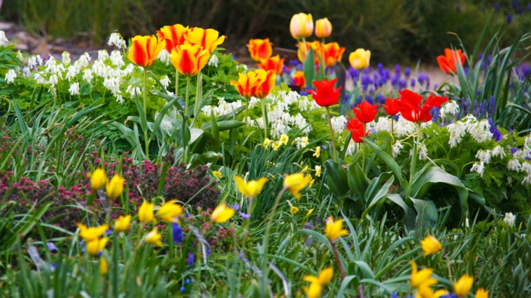
Holly Village Resident Spring Cleanup

It's time for spring cleaning. We wish to inform the community we will be providing dumpster(s) for our residents to use for a 10-14 period. The dumpster(s) will be located on Adams Drive near the mail pavilion and are for the removal of any debris from yard cleaning/spring cleaning. Loose leaves etc. need to be bagged before throwing them away. You may also use the dumpsters to remove small unwanted household items/clutter. Loose items must be bagged. The dumpsters are for residents only.

Please note there are many restricted items that cannot be put in these dumpsters as per the policies of the vendor, C&H Disposal and landfill and government laws for waste removal. Violators will be reported, fined etc.

Please note if the dumpsters are full, do not put anything in them or leave anything on the ground around them. You will need to wait for dumpsters to be emptied. The dumpsters cannot overflow and trash must be level. If full, do not add to it. Wait for another empty dumpster to arrive.
Please check availability prior to bringing your trash for disposal.

RESTRICTED ITEMS The following items are not allowed;

No tires, No appliances (fridge, oven, washer/dryer etc.)
No Asbestos, No hazardous and/or flammable items
No paint/paint thinner, No oil, grease, or oily rags. No coolants (anti-freeze etc.)
No Batteries, No Fluorescent tubes/bulbs
No Medical waste, No pesticides/herbicides

The dumpster(s) will be at Adams Drive on Tuesday, May 2nd.

They will be available approximately 10-14 days. Please check dumpster availability prior to bringing your trash to make sure they are not full and onsite.

If you have any questions, please contact the office.
hollyvillagengk@gmail.com - www.hollyvillagenj.com
Holly Village - 856-825-3083

